­­­­­What is software testing?

The process of testing application with the intent to test the application is called as Software testing

What is Manual testing

The process of testing the application without tool is called as manual testing.

What is automation testing?

The process of testing the application using tool is called as Automation testing

Advantages of Automation testing

1. Time and cost reduction
2. Accuracy
3. Reusability or Repeatability
4. Consistency
5. Quality

What is selenium

Selenium is an open source web automation tool.

Components of selenium

1. Selenium IDE
2. Selenium GRID
3. Selenium Webdriver

Advantages Selenium

1. Open source
2. Multiple Browsers( Chrome, Safari, Edge, Firefox and Opera)
3. Multiple platforms (Windows, MAC, Linux)
4. Multiple programming languages ( Java, Python, JavaScript etc...)
5. Easy to integrate with other testing frameworks like TestNG, JUnit, JMeter etc…
6. Large community of people using selenium.

Dis-advantages of selenium

1. Can’t automate MP3, MP4 related test cases.
2. Can’t automate OTP & Captcha related test cases.
3. Can’t automate QR code bar code related test cases.
4. Only web applications can be automated.
5. Gaming applications can’t be automated.
6. Desktop and standalone applications can’t be automated.

Selenium architecture

* Client (WebDriver client library & language binding) 🡪 To send request to the server
* W3C protocol 🡪 To send request to driver
* Driver executable files 🡪 Mediator between Client and Browser
* Browser 🡪 Actual browser which responds to client request.

Selenium WebDriver ­architecture

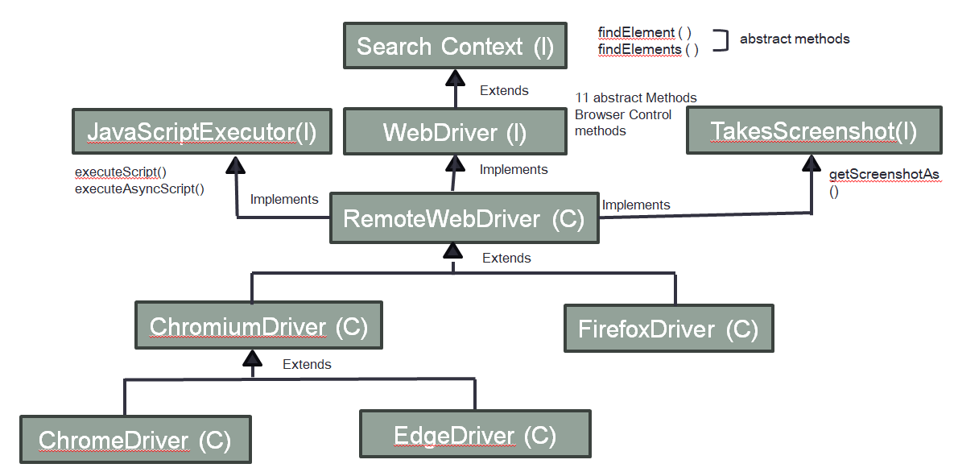

WHAT IS WebDriver or explain WebDriver methods

WebDriver is an Interface present in selenium to handle browser window

1. get(String url) 🡪 To enter URL or to navigate to webpage
2. getTitle() 🡪 To get the title
3. getCurrentUrl() 🡪 To get the URL
4. getPageSource() 🡪 To get the source code
5. getWindowHandle() 🡪 To get the id / name of current window. Returns String
6. getWindowHandles() 🡪 To get the id / name of all the windows. Returns Set<String>
7. manage() 🡪 Used to call maximize, minimize the fullScreen() methods
8. navigate() 🡪 Used to navigate to URL, navigate back(), navigate forward() and refresh()
9. switchTo() 🡪 To switch the driver control to alert, window, frame or active element
10. close() 🡪 To close only the current window
11. quit() 🡪 To close all the windows and to close driver session

Explain Locators

Locators are used to find the location web element in the webpage.

There are 8 types of locators, they are static methods present in By abstract class

1. id()
2. name()
3. className()
4. tagName()
5. linkText()
6. partialLinkText()
7. cssSelector()
8. xpath()

xpath()

* XPath stands for XML path. It is a syntax for finding any element on a web page using XML path expression. XPath can be used in HTML documents to find the location of any element on a webpage using HTML DOM structure.

* In Selenium automation, if the elements are not found by the general locators like id, class, name, etc. then XPath is used to find an element on the web page.

* XPath is slow compared to all other locators.

* There are two types of XPath:

1) Absolute XPath

2) Relative XPath

Absolute XPath:

* Specifying complete path of the element from the root, till the element is called as absolute xpath.

* It is the direct way to find the element.

* The disadvantage of the absolute XPath is that if there are any changes made in the path of the element then that XPath gets failed.

* The key characteristic of Absolute XPath is that it begins with the single forward slash(/) ,which means you can select the element from the root node.

Syntax:

/html/body/div[2]/div[1]/div/input

* First forward slash (/) represents root tag

* Forward slash after tagname (/html/) represents all immediate tags

Relative xpath -

* Relative xpath can be written using "//" and "/". "//" represents all child tag. "/" represents immediate child tag.

syntax: //tagName//child_tag_name

//tagname/child_tag_name

**Types of relative XPath**

* xpath by attribute
* xpath by text function
* xpath by contains function
* xpath by traversing
* forwarding xpath
* backward traversing
* xpath by index

Diff b/w cssSelector and xpath

|  |  |
| --- | --- |
| **cssSelector()** | **Xpath()** |
| Faster | Slower |
| Can’t use text() | text() can be used |
| Can’t use contains() | contains() can be used |
| Backward traversing not possible | Backward traversing is possible |

Explain WebElement methods

Anything which is present in the webpage is called as WebElement. To perform action on the web element WebElement interface methods are used.

There are 14 methods in WebElement

1. click()
2. clear()
3. sendKeys()
4. submit()
5. isDisplayed()
6. isEnabled()
7. isSelected()
8. getText()
9. getCssValue()
10. getAttribute()
11. getTagName()
12. getSize()
13. getLocation()
14. getRect()

Difference between findElement() and findElements()

|  |  |
| --- | --- |
| **findElement()** | **findElements()** |
| Used to handle single web element | Used to handle multiple webelements |
| Return type is WebElement | Return type is List<WebElement> |
| If multiple matching found it returns first matching element | If multiple matching found it returns all the matching element |
| If no matching found findElement() will throw NoSuchElementException | If no matching found findElements() will return Empty List<WebElement> |

Explain how to handle list box/dropdown

If dropdown is created using select tag, then it can be handled using the methods of Select class.

Select select =new Select(WebElement dropdown);

There are 12 methods in select class

1. selectByIndex()
2. selectByValue()
3. selectByVisibleText()
4. deselectByIndex()
5. deselectByValue()
6. deselectByVisibleText()
7. deselectAll()
8. isMultiple()
9. getOptions()
10. getAllSelectedOptions()
11. getFirstSelectedOption()
12. getWrappedElement()

Mention the different types of pop ups.

Popup is a window that displays or pops up on the screen due to some activity.

Pop up types

* Alert or Javascript
  + Simple
  + Confirm
  + Prompt
* Child window
* File upload
* File download
* Notification
* Authentication
* Calendar

How to handle Alert pop up

**Alert pop up can be handle by using:**

driver.switchTo().alert().accept()

driver.switchTo().alert().dismiss()

driver.switchTo().alert().getText()

driver.switchTo().alert().sendKeys()

Explain how to handle child window pop up

Child window pop up can be handled by using “ driver.switchTo().window(windowId);”

getWindowHandle() and getWindowHandles();

Explain synchronization

Synchronization is the process of matching the speed of selenium with speed of webapplication.

There are three types waits in selenium to achieve synchronization.

1. Implicit wait

Syntax : 

1. Explicit wait or WebDriverWait

**Syntax:**

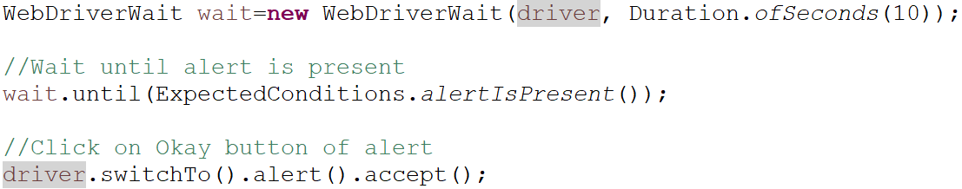

1. FluentWait

FluentWait is used to change the polling time. (Default Polling time for all waits is 500ms)

­­­ 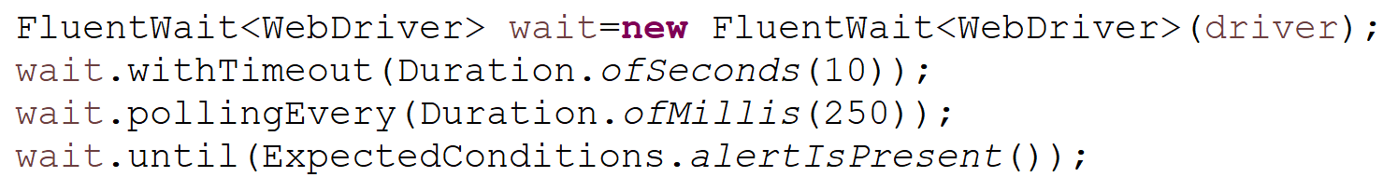

diff b/w implicitlyWait and explicit wait

|  |  |
| --- | --- |
| implicitlyWait() | WebDriverWait |
| Write only once in a program | Write whenever wait needed |
| Works only for findElement and findElements | Works for all the methods |
| If Timeout we get noSuchElementException | If Timeout we get TimeOutException |

How to handle mouse and Keyboard actions?

In Selenium mouse and keyboard actions can be handled using Actions Click

Actions action=new Actions(driver);

1. moveToElement()
2. click()
3. contextClick()
4. doubleClick()
5. clickAndHold()
6. release()
7. dragAndDrop()
8. scrollByAmount()
9. scrollToElement()
10. scrollFromOrigin()
11. keyDown()
12. keyUp()
13. perform()

Explain about Robot class

Robot class is used to handle actual mouse and keyboard actions

Robot robo=new Robot();

1. mouseMove()
2. mousePress()
3. mouseRelease()
4. keyPress(KeyEvent.VK_SHIFT);
5. keyRelease(KeyEvent.VK_SHIFT);

How to handle elements present in frame?

Frame is used to embed one html page inside another html page.

Driver focus should be switched to frame in order to handle the elements present inside frame.

1. driver.switchTo().frame(int index)
2. driver.switchTo().frame(String nameOrId)
3. driver.switchTo().frame(WebElement element)
4. driver.switchTo().parentFrame()
5. driver.switchTo().defaultContent()

How to take screenshot in Selenium?

Screenshot can be taken by using “ getScreenshotAs()” method of TakesScreenshot interface.

Webpage screenshot:

­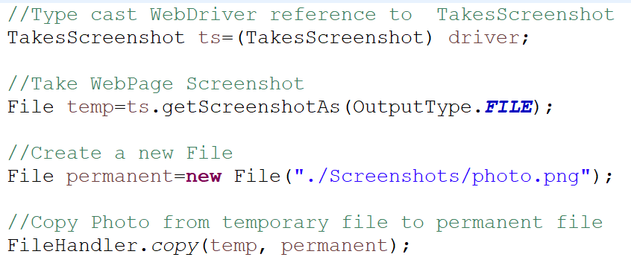

WebElement Screenshot:

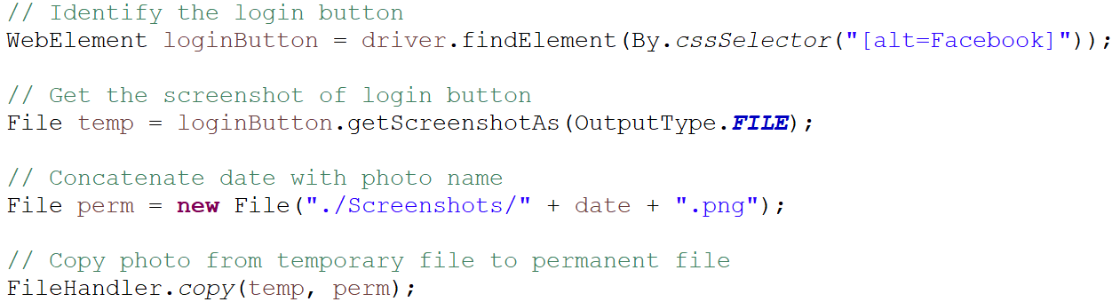

Mention some of the exceptions you know in selenium

1. WebDriverException
2. TimeoutException
3. NoSuchElementException
4. StaleElementReferenceException
5. InvalidSelectorException
6. NoSuchFrameException
7. NoAlertPresentException
8. UnhandledAlertException
9. SessionNotCreatedException­
10. ElementNotInteractableException
11. ElementClickInterceptedException
12. JavaScriptException

Explain TestNG

TestNG is a testing framework, by using we can execute test scripts without main method. And also we can perform:

* Batch execution
* Group execution
* Parallel execution
* Annotations
* Skip test cases(dependsOnMethods)
* Priority
* Dependency
* Listeners
* Assertions

Explain all different types of annotation.

@BeforeSuite

@BeforeTest

@BeforeClass

@BeforeMethod

@Test

@AfterMethod

@AfterClass

@AfterTest

@AfterSuite

Explain Assertion

* Assertion is the feature in java to validate some critical checkpoints.
* There are two types of assertions

1. Hard assert
2. Soft assert

Hard Assert: Used to validate mandatory checkpoints.

* Hard assert methods are static methods present in Assert class
* Syntax:
  + 
* If actual and expected are not matching, then Hard Asser will stop the execution.

SoftAssert : Used to validate non mandatory check points

* SoftAssert methods are non static methods present in SoftAssert class
* Syntax:
  + 
* If actual and expected are not matching, then Soft Asser will stop the execution. It will complete the execution and fail the test script in the last.
* assertAll() method is mandatory in SoftAssert

Difference between Hard assert and soft assert or explain diff between Assert and Verify­

|  |  |
| --- | --- |
| **Hard Assert** | **SoftAssert** |
| Static methods present in Assert class | Non static methods present in SoftAssert class |
| In case of failure test case will be terminated abruptly | In case of failure test case will be terminated abruptly |
| No need to call any method to show assertion failure. | We need to call assertAll() method to show assertion failure. |

What is POM

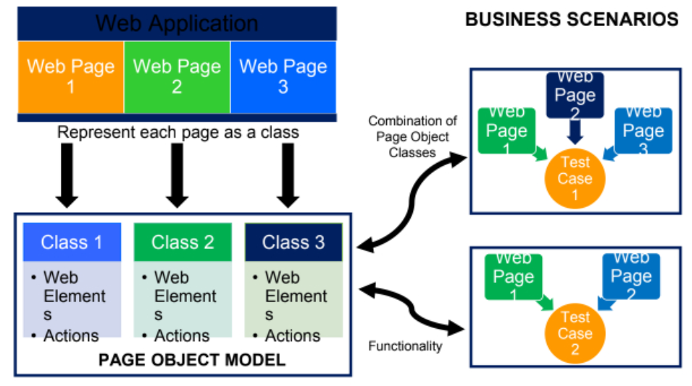

* It is a design pattern which is used in automation to write test scripts independent of the web element identification.
* We write a separate java class for each and every page of web application.
* It is also called as Object repository

How to create POM class

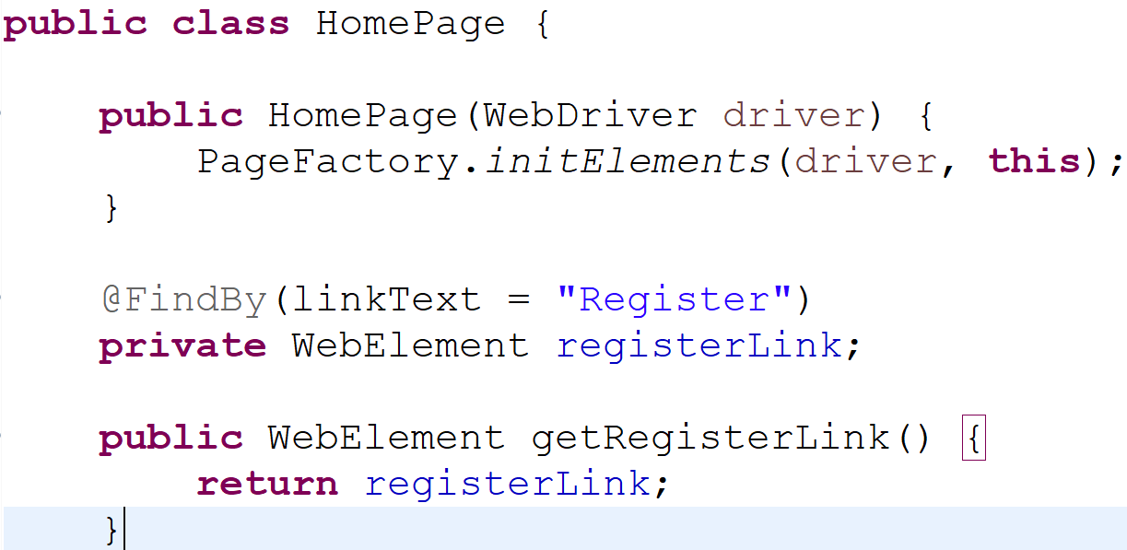

**Advantages of POM**

* To handle stale element reference exception
* Maintenance of web element is easy
* Reusability of code
* Readability of code is easy.

Explain where you have used OOPs in your framework.

1. Inheritance 🡪 BaseClass to all Test class and BasePage to all Page class

What is Framework and what are the different types of framework

Framework:

- Framework is a set of rules and guidelines or best practices to be followed while

automating any application.

Or

- Framework is a collection of reusable components that makes automation test

script development, execution and modification to be easier and faster.

Or

- Framework is a well organized structure of reusable components where one

driver script (testng.xml) will take care of entire batch execution without any

manual intervention

**Different types of frameworks available**

1. Keyword driven framework
2. Data Driven framework
3. Modular driver framework
4. Behaviour driven framework
5. Hybrid Framework

Explain your frame work

Framework is a set of rules and guidelines or best practices to be followed while

automating any application.

- Inorder to execute the test script with multiple inputs or test data, we use an excel and property file, so we call our framework a Data driven framework.

- Inorder to avoid writing repetitive steps again and again we use lots of reusable methods, so we call our framework a method driven framework.

- Since we maintain our framework module wise, we also call our framework a Modular driven framework.

- Since it is a combination of 2-3 frameworks hence it is called a Hybrid driven framework.

- In the beginning of the execution first it executes the BaseClass which is present in the Generic package which contains all the configuration methods like @BeforeClass, @BeforeMethod, @AfterMethod and @AfterClass.

First it executes the @BeforeClass which contains the code for opening the browser, then it will execute the Login code which is present in @Beforemethod.

- Then it will executes the @Test method where actual test scripts are written in test script package, while executing the test scripts it will take the test data from the excel file with the help of Apache POI jars and performs action on the GUi

application by calling necessary methods present in the POM class.

- Once it executes the test method it will execute the Logout code which is

present in @AfterMethod.

- Like this it will execute all the test cases one after the other with help of Batch

runner(testng.xml).

- After the execution of all the test cases it will close the browser which is present

in @AfterClass.

Explain framework components

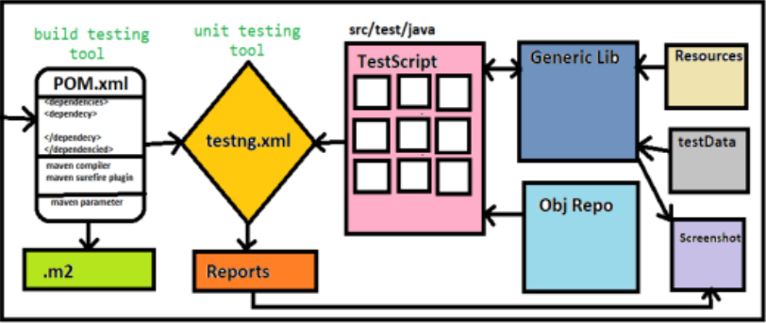

What is the advantage of maven project

What is method overloading?

A Class having methods with same name but differing formal arguments is called as method overloading.

Ex:

Class{

Public static void m1(){

System.out.println();

}

Public static void m1(int a){

System.out.println();

}

What is method overriding?

The process of replacing parent method by the child method body is called as method overriding.

What is class?

A Class is simply a representation of a type of object. It is the blueprint/plan/template that describes the details of an object. Every classes having capacity to store more than one information.

What is Object? And how to create object in java?

Anything in the real world which is having existence and STATES and BEHAVIOUR is called as object.

States of an object is represented by Non-static variable.

Behaviors of an object is represented by non-static method.

how to create object in java?

In Java, the **new** keyword is used to create new objects.

What is OOPs? Explain OOPs

Oops stands for Object Oriented Programming System in which Programs are consider as a collection of Objects. Each object is nothing but an instance of class.

Explain Encapsulation

The process of binding STATES and BEHAVIOURS together is called as Encapsulation.

We can create a fully encapsulated class in Java by making all the data members of the class private. Now we can use setter and getter methods to set and get the data in it.

Explain Inheritance

The Process of acquiring STATES and BEHAVIOURS of one object into another object is called as Inheritance.

In java we can achieve inheritance with help of two important keywords that is,

1.extends

2.Implements

**Types of Inheritance?**

**1.Single level inheritance**

Inheritance of only one level is known as Single level inheritance.

**2.Multilevel inheritance**

Inheritance of more than one level is called as Multi level inheritance.

**3.Hierarchical inheritance**

If a parent has more than one child at the level then it is known as Hierarchical inheritance.

**4.Multiple inheritance**

If a class has more than one parent then it is known as Multiple inheritance.

**5.Hybrid inheritance**

The combination of multiple inheritance and hierarchical is known as hybrid inheritance.

Explain Polymorphism

The ability of an object having same name, but different name is called as Polymorphism.

Polymorphism is derived from Greek, when Poly indicated many and morphism indicates forms.

Explain Abstraction

The process of providing important features, but hiding implementation is called as Abstraction.

*Interface:*

It is similar to class and the component of java. We go for interface to achieve 100% abstraction and multiple inheritance.

Explain typecasting (upcasting, downcasting and explicit typecasting)

**Typecasting**

It is the process of converting one data type into another data type is called as type casting.

**Up casting**

The process of storing child objects in the parent type of container is called as up casting.

**Down casting**

The process of storing the parent objects reference in the child type of container is called as down casting.

Explain Exception

Exception is sudden stop or abrupt stop during the execution of the program at the run time.

Whenever exception arrives Throwable type of object is created. Execution of the application is stop.

**Two types of exception:**

1. Checked Exception
2. Unchecked Exception
3. **Checked Exception:**

Checked exception mean compiler aware exception

Ex:

1. Interrupted Exception
2. SQL Exception
3. IO Exception
4. AWT Exception
5. **Unchecked Exception:**

Unchecked exceptions mean compiler unaware exception.

Ex.

1. Arithmetic exception

2. Null point exception

3. Class cast exception

4. IndexOutOfBounceException

1. ArrayIndexOutOfBounceException

2. StringIndexOutOfBounceException

**Explain Exception handling**

The process of maintain the normal flow of an execution of the program by using try and catch block is called as exception Handling.

Exception handled means catch is successful.

Exception not handled means catch not is successful.

**Explain List**

List is a collection of objects. It is ordered collection of objects. It has indexing therefore we can access insert, remove or access the element with help of index.

List can have duplicate objects.

We can access the list using following ways which is given below,

1. get method
2. iterator
3. List iterator
4. For each loop or Advance for loop

**Explain Set**

It is an interface. It is rule interface of collection. All the methods of collection interface are inherited to set interface.

Set interface is present inside in java.util.package.

***Explain Arrays***

Array is a contiguous memory block which is used to store homogenous element.

A word contiguous means next to one another.

**Two ways to create arrays**

1. Dynamic Array

2. Static Array

**Syntax for Dynamic Array**

1. **Declaration Statement:**

datatype[] refvariable;

1. **Declaration and initialization statement:**

datatype[] refvariable=new datatype[index size]

**Syntax for Static Array**

Datatype[]variable={v1,v2,v3….};

**Explain Multi-Dimensional Arrays**

One Array present inside another array is called as multi-dimensional array.

**Two ways to create multi-dimensional arrays**

1. Dynamic Array

2. Static Array

**Syntax for Dynamic Array**

1. **Declaration Statement:**

datatype[][] refvariable;

1. **Declaration and initialization statement:**

datatype[][] refvariable=new datatype[row size][column size];

**Syntax for Static Array**

datatype[]variable={{v1,v2,v3},{v1,v2,v3},{v1,v2,v3}….};

**Explain String**

String is a sequence of characters. But in Java, string is an object that represents a sequence of characters. The java.lang.String class is used to create a string object.

**How to create a string object?**

There are two ways to create String object:

1. By string literal
2. By new keyword

### 1) String Literal

Java String literal is created by using double quotes. For Example:

1. String s="welcome";

### 2) By new keyword

String s=**new** String("Welcome");//creates two objects and one reference variable

Write a program to reverse given String

WAJP to reverse array

WAJP to check palindrome

WAJP to find prime number

WAJP to find the frequency of the character

WAJP to find the duplicate array elements

WAJP to remove duplicates

WAJP to find factorial of a number

Replace String EX: “I love Biriyani” Result=”I hate Biriyani”

­­Collection framework programs